9.4.2-A CUSTOMER AUTHENTICATION [E1]

SECTION 1: CONTROL REQUIREMENTS OVERVIEW

9.4.2-A – Scope
​Control covers Consumer and Enterprise Customer access to high-risk transactions and / or sensitive data via customer portals on-premises and in the private or public Cloud (SaaS)

9.4.2-A – Test Sample to Include
​Test sample to include
- Consumer portal: MVA Online portal
- Enterprise customer portal: EVC Org portal

[E1] CSB Requirementsvc
[E1]
Evidence showing the configuration of MFA, including the type of MFA configured. Screens shots of the process in place or logs showing the MFA authentication occurring.
SECTION 2: [E1] EVIDENCE ITEMS

9.4.2-A CSB [E1] Evidence Items
Consumer portal: MVA Online portal
1. | Evidence showing the configuration of MFA, including the type of MFA configured
1.1.1 | Customers log onto the portal using their unique MSISDN [username] and password. Once the customer has entered a valid username and password the customer is required to provide with a second method of authentication. Screenshot below demonstrating the logon page with the customer MSISDN [username] and password.  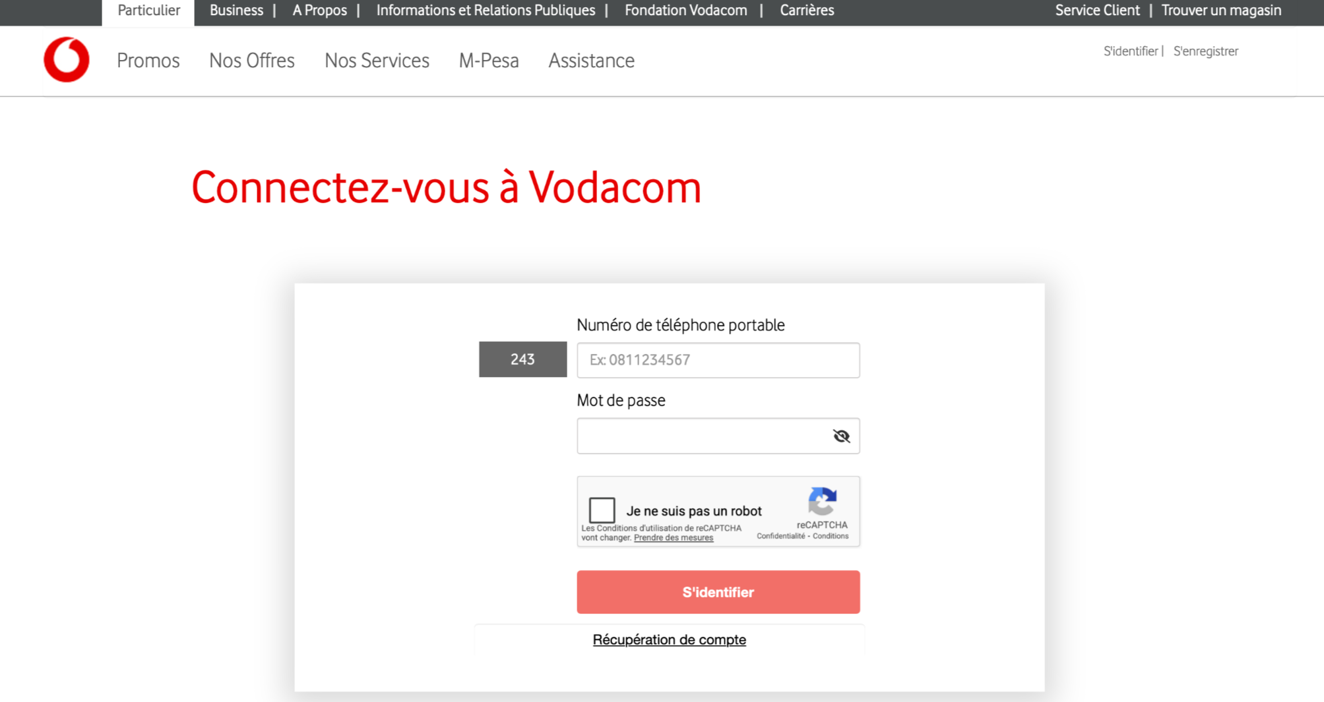  Legend [Translation from French to English]  Numero de telephone portable = User’s phone number  Mot de passe = user’s password  Screenshot below demonstrating the second page where the customer is required to enter OTP [One Time Password]. The OTP is sent to the customer to be able to prove that they are who they say they are.  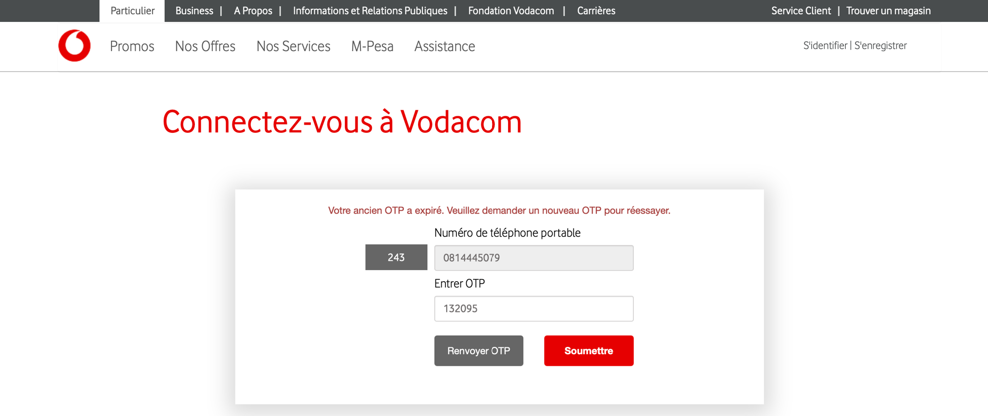  The OTP is configured to either be sent to the customer via email and or via SMS. During registration the customer can choose one of the options. Screenshot below demonstrating the MFA type[ Which method the OTP is sent to the customer].  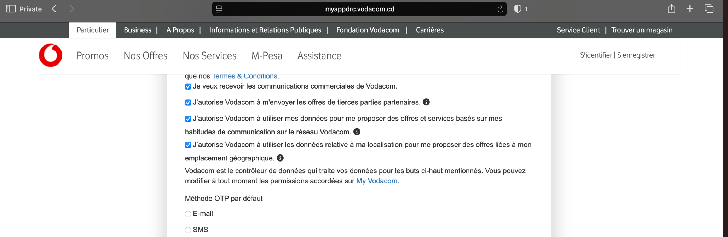  Type of MFA  Extract from the log demonstrating customer OTP being sent to the customer via SMS and being accepted by the system.
Enterprise customer portal: EVC Org portal
2. | Evidence showing the configuration of MFA, including the type of MFA configured
2.1.1. | Screenshot below extracted from the portal demonstrating the login page, Customers are required to provide with their username and password including short code.  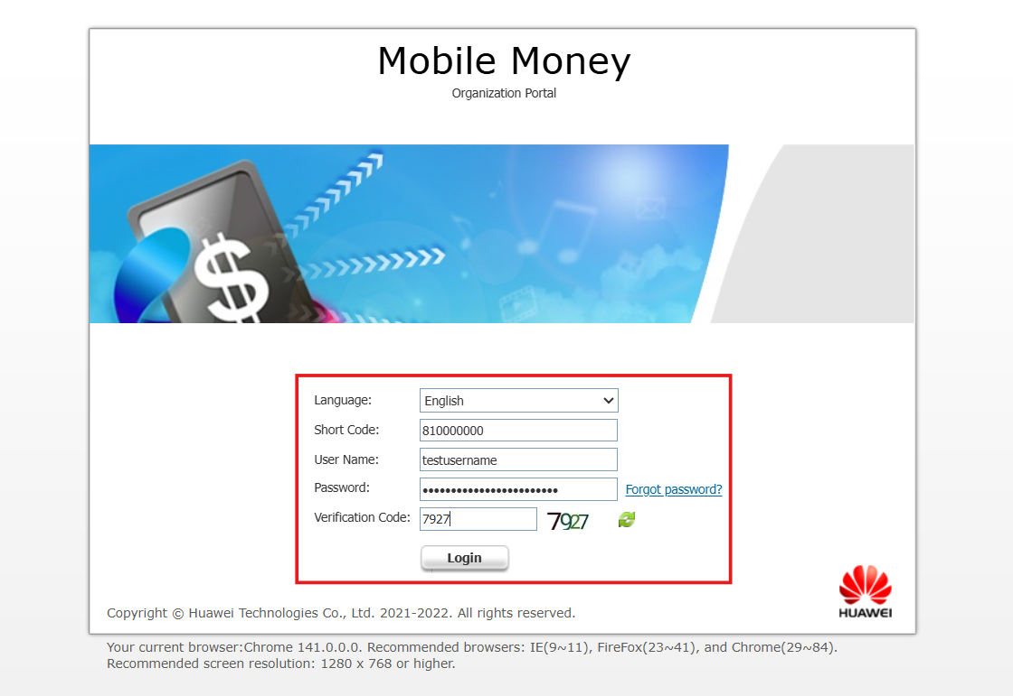  Once the customer has been authenticated using the username and password, the customers is required to provide with a One -Time-Password [OTP] as MFA. Upon registration the customer would choose the method of OTP delivery. Options available include SMS and or email.  Screenshot below demonstrating the MFA types.  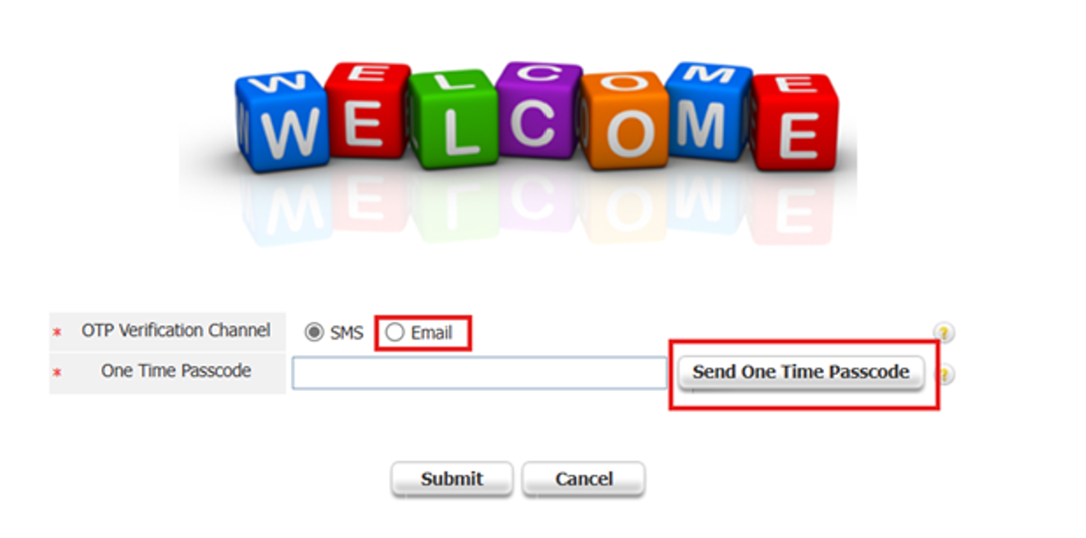  Extract below from the mail received by the client on the OTP sent via email.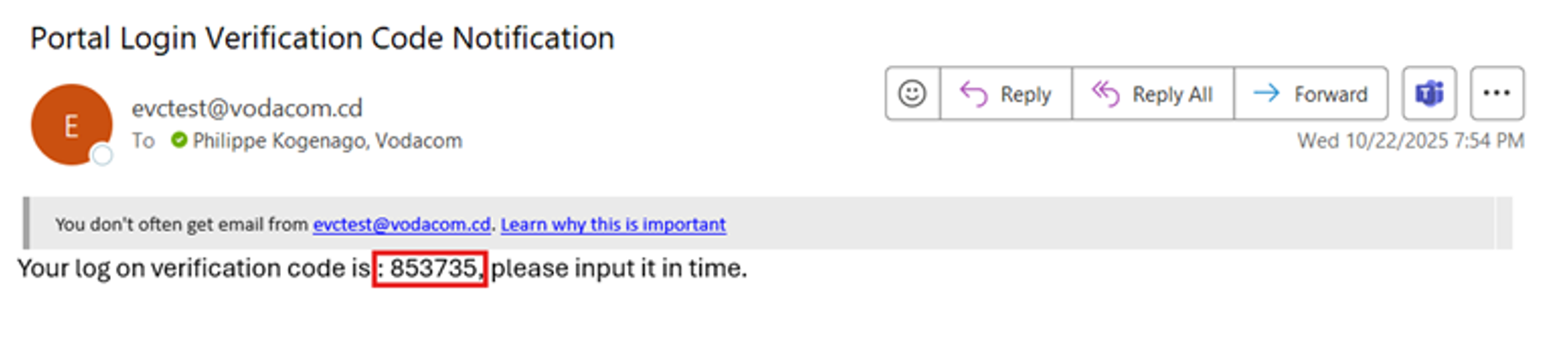  Example of OTP sent to the customer via SMS.  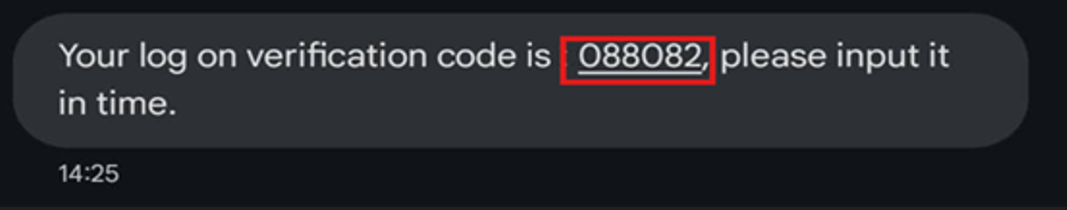  Example below extracted from the logs demonstrating logs after the customer has been fully authenticated after OTP validation.  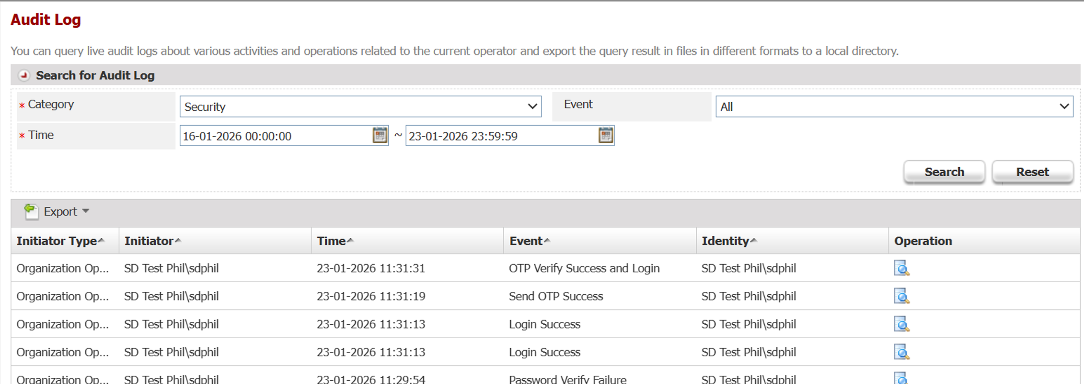
------------------------------- End of Document -------------------------------

